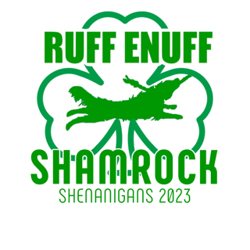
Local Restaurant List
Tavern in the Square Littleton  $$$ · American  810 Constitution Avenue, Littleton · In The Point  Phone: (978) 339-5372 | Not Your Average Joe’s  $$ · American  305 Main Street, Acton  Phone: (978) 635-0101
Il Forno Restaurant  $$$ · Italian  529 King Street, Littleton  Phone: (978) 540-2880 | Moe's Southwest Grill  $ · Mexican  607 Constitution Avenue, Littleton · In The Point  Phone: (978) 506-5154
Great Road Kitchen  $$$ · Oyster/American Bar/Grille  613 Constitution Avenue, Littleton · In The Point  Phone: (978) 952-7333 | Asian Plus Noodles and Rice  $ · Asian  313 Littleton Road, Westford  Phone: (978) 577-6425
Taka Asian Cuisine  $$$· Asian (Chinese/Japanese/Thai)  602 Constitution Ave, Littleton · In The Point  Phone: (978) 339-5498 | Lazy Mary’s  $ · Pizza/Sandwiches  30 Littleton Road, Ayer  Phone: (978) 772-7600
Anthony's Coal Fired Pizza  $$ · Pizza  201 Constitution Avenue, Littleton · In The Point  Phone: (978) 486-4124 | Chip Shots Pub  $ · Pizza/Burgers/Sandwiches  245 Ayer Road, Littleton  Phone: (978) 772-0072
Chili’s Bar & Grill  $$ · American  137 Littleton Road, Westford  Phone: (978) 692-8498 | Subway  $ · Sandwiches  287 Great Road, Littleton  Phone: (978) 486-9782
Ixtapa Cantina
$$ · Mexican
765 Boston Road, Groton
Phone: (978) 272-1465

